How to retrieve ScanFold results from the website

Step 1 — Open the database portal
Go to the RNAStructuromeDB portal:
https://structurome.bb.iastate.edu/azt/
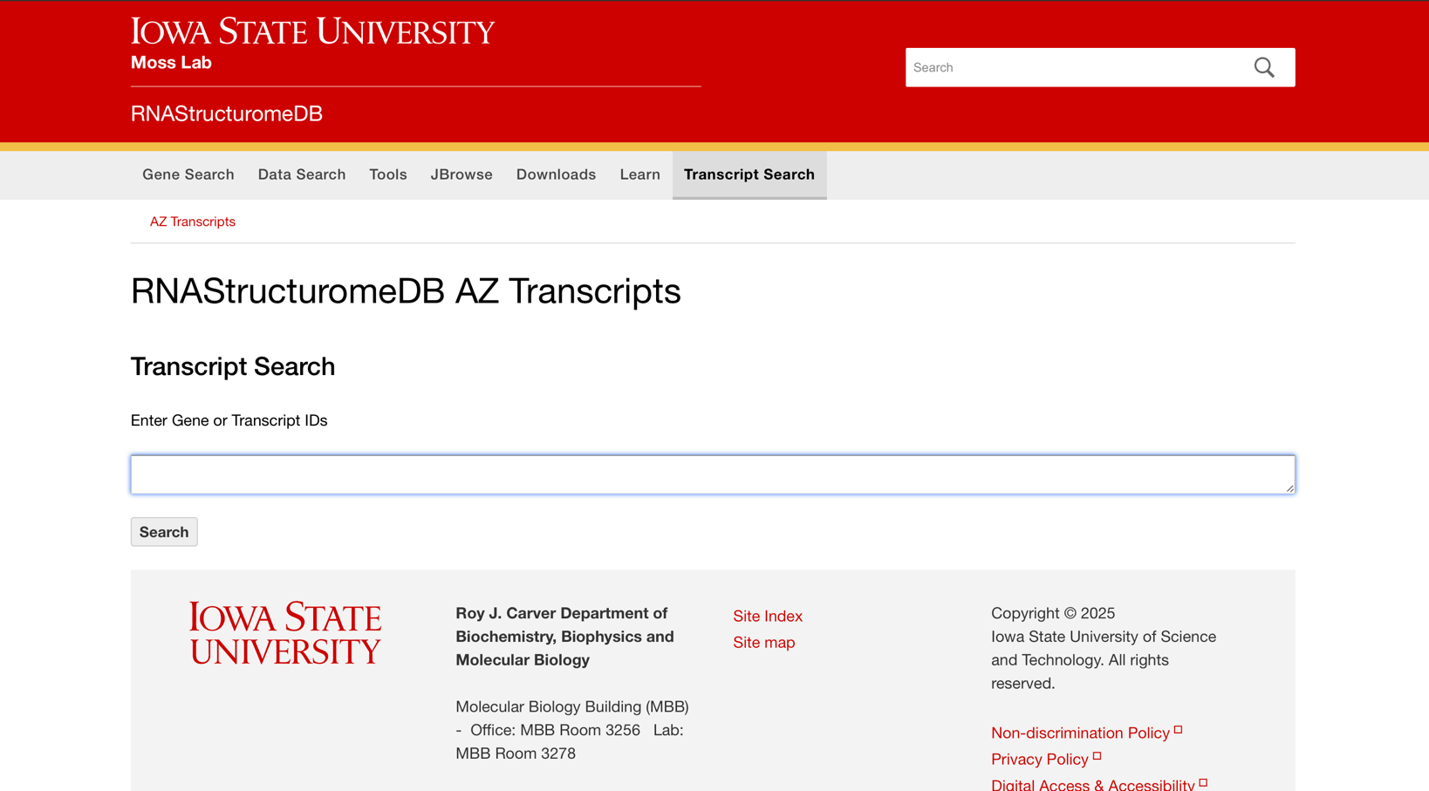

Step 2 — Search using an Ensembl transcript ID (ENST)
In the search box, enter an Ensembl Transcript ID (e.g., ENST00000351205.8).
Note: The current search interface expects Ensembl IDs (transcript or gene); gene symbols/names are not accpeted.
Click Search.
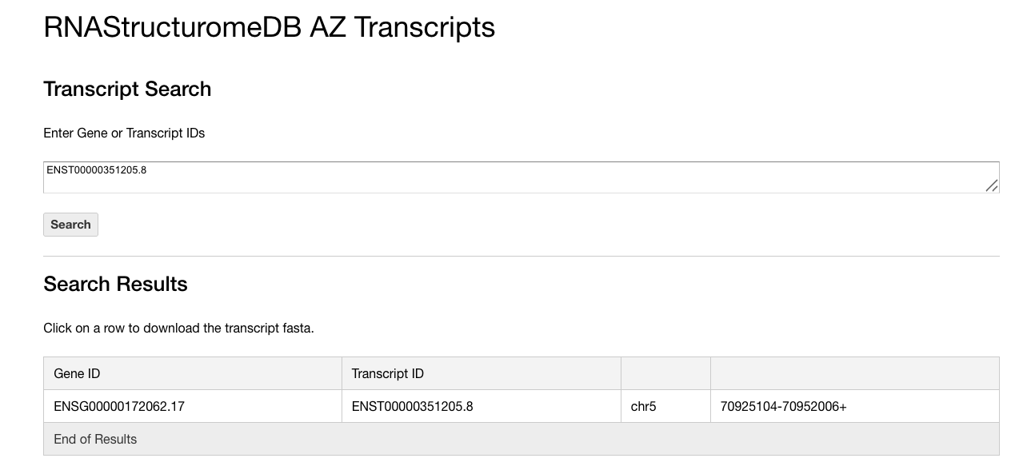

Step 3 — If you searched by gene, choose an isoform (transcript)
If you searched using a gene-level identifier and multiple isoforms appear, select the transcript/isoform you want (the ENST entry).
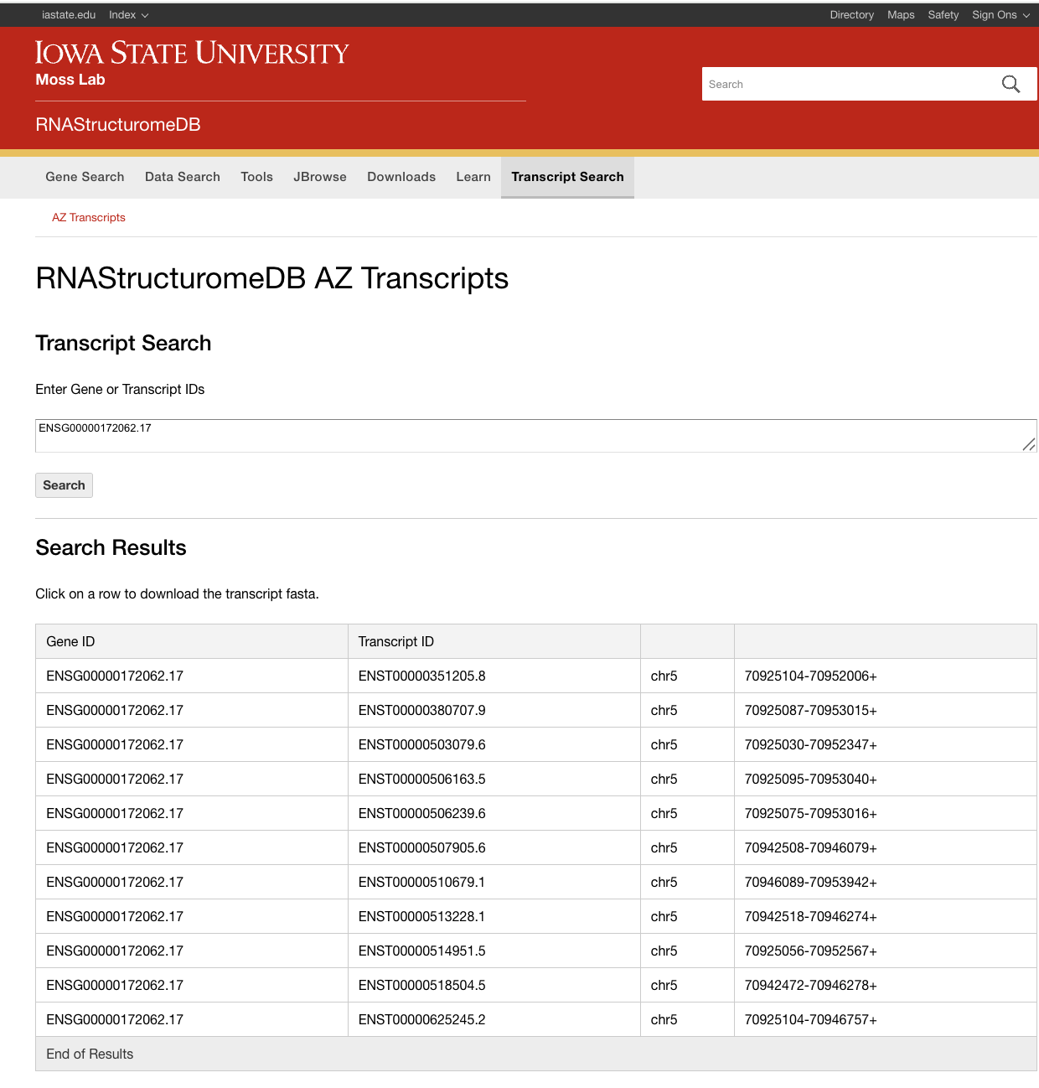

Step 4 — Download the precomputed ScanFold package (ZIP)
Just click the row for the transcript you’re interested in—this will automatically start downloading the corresponding output ZIP file.

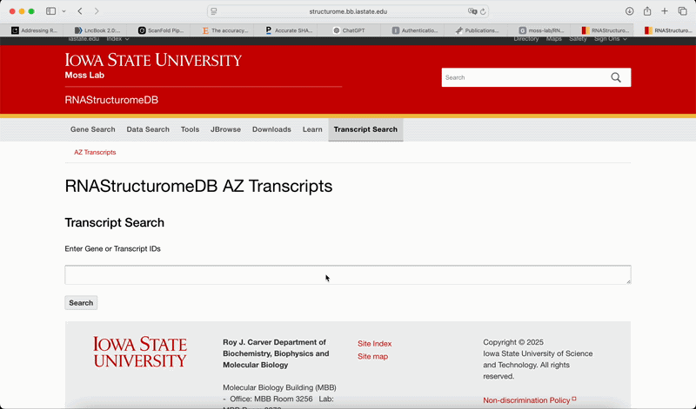

Step 5 — Unzip and inspect the contents
Unzip the downloaded file. Inside, you will find:
- Sequence: .fasta
- Windowed Scan results: .tsv
- Extracted sub-motifs: .txt
- Consensus structures (two thresholds, −1 and −2):
  - dot-bracket: .dbn
  - connectivity table: .ct
- A folder containing genome browser tracks (for IGV visualization)
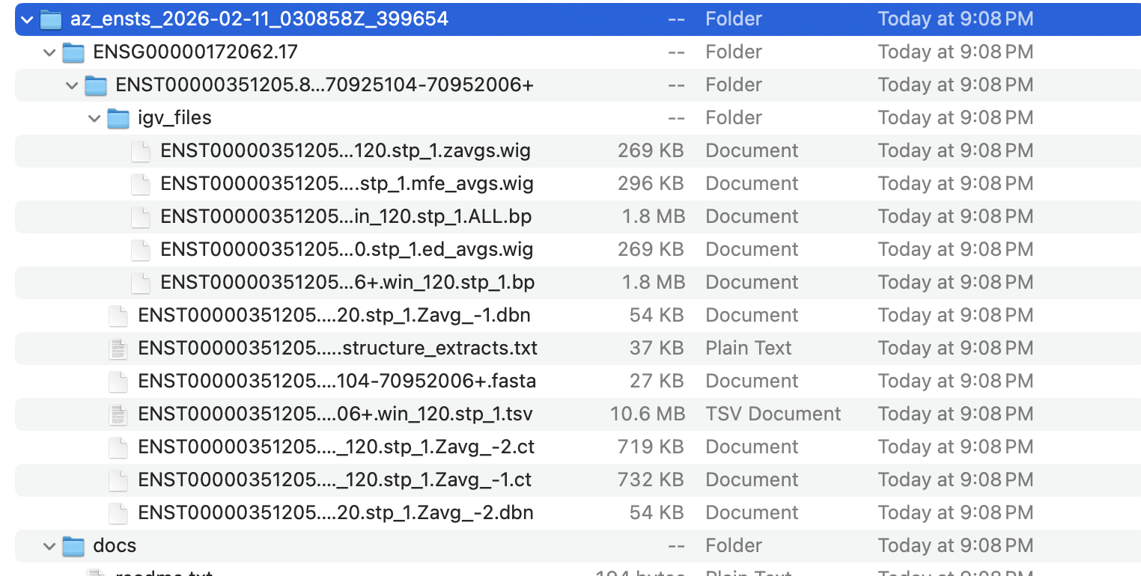

Step 6 — Visualize tracks in IGV (optional)
Open IGV and load the track files from the included tracks folder.

How to retrieve the same data programmatically with RNA-Annotator

Step 1 — Install RNA-Annotator and dependencies
Follow the installation instructions in the repository:
https://github.com/moss-lab/RNA-Annotator-v1

Step 2 — Download ScanFold outputs for a transcript
Run RNA-Annotator using an Ensembl transcript ID:
python rna-annotator.py ENST00000263100.8 \
-download_scanfold
This downloads the precomputed ScanFold package for that transcript.

Step 3 — Generate IGV-ready ScanFold tracks (optional but recommended)
To automatically generate the main ScanFold visualization tracks:
python rna-annotator.py ENST00000263100.8 \
-download_scanfold \
-scanfold_bp \
-scanfold_mfe \
-scanfold_zscore \
-scanfold_ed
This produces IGV-ready tracks for:
- Base-pair arcs (-scanfold_bp)
- MFE (-scanfold_mfe)
- z-score (-scanfold_zscore)
- ensemble diversity (-scanfold_ed)

Step 4 — Load tracks automatically in IGV (macOS/Linux)
If IGV is installed, you can optionally launch/load tracks automatically:
python rna-annotator.py ENST00000263100.8 \
-download_scanfold \
-scanfold_bp -scanfold_mfe -scanfold_zscore -scanfold_ed \
-igv \
--igv-path "/Applications/IGV_2.16.2.app"

Step 5 — Where outputs are saved
RNA-Annotator writes outputs into two main folders:
- results/detailed_results/ → tabular .tsv/.csv outputs for each annotation layer
- results/bed_tracks/ → browser-ready track files (.bed, .wig, .bedGraph, etc.)

